New Mesh using %<---test1.geo (modified)----------
Field[1] = Attractor;
Field[1].NodesList = {10, 11, 12, 13, 14, 15, 16, 17, 18, 19};
Background Field = 1;
--->%
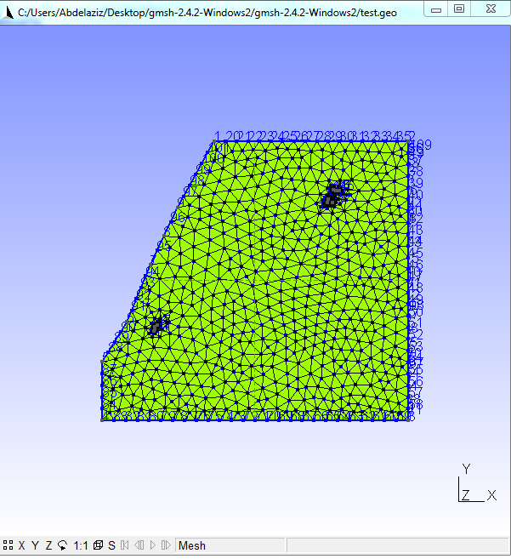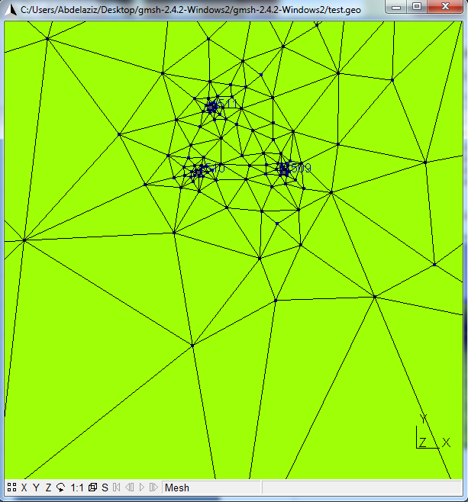
Old Mesh using %<---test.geo (received)----------
Attractor Point{10} ={xx,xx,i};
Attractor Point{11} ={xx,xx,i};
Attractor Point{12} ={xx,xx,i};
Attractor Point{13} ={xx,xx,i};
...
Attractor Point{19} ={xx,xx,i};
--->%
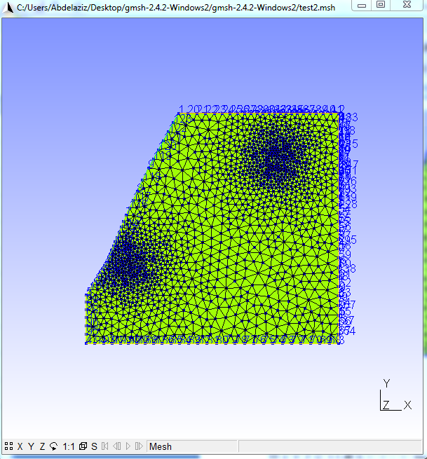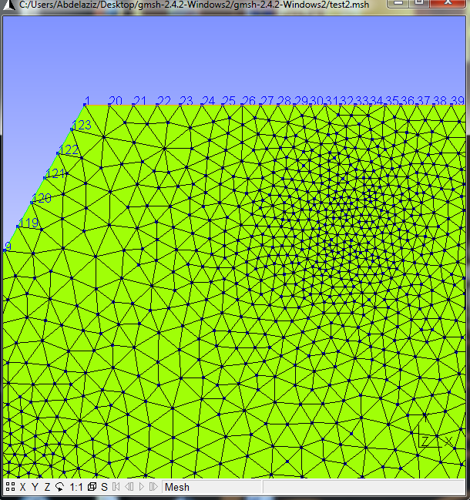
There is a large difference between the two meshs. The old mesh is significant, especially angles, they are homogeneous. Now the question arises: Can we have the old mesh with the new version of MSGH ? I hope that the response is “yes” ☺ , else I want to know what is the version that use : Attractor Point{10} ={xx,xx,i}; ….

