Node numbering inconsistency in version 1.54.1

In this example two surfaces are bonded together by a third surface, figures (1, 2). These surfaces are produced with the isotropic algorithm.

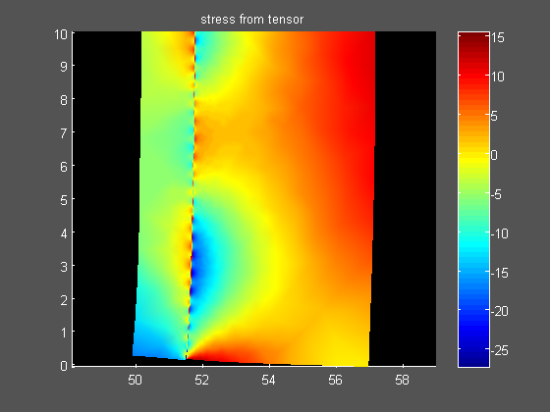

Figure 1

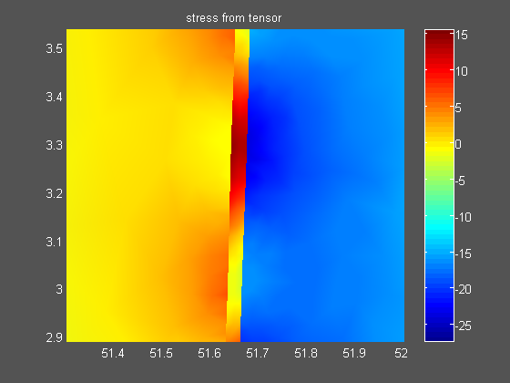

Figure 2

The third surface however seems to have another rotating direction.

When we filter the tree surfaces (renumbering routine) we get the right solution, figure 3.

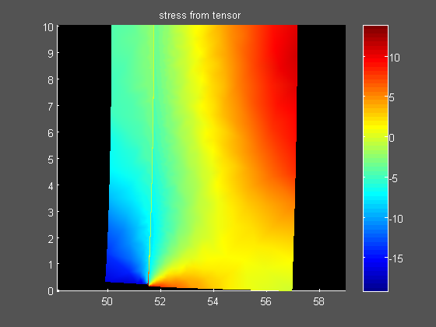

Figure 3

I hope this information will help you to optimize your mesh algorithm.

